Purpose and Scope
To ensure the proper maintenance and inspection requirements are identified and met for the safe and correct use of equipment.

Process Responsibilities
- Identifying Key Equipment

1. Warehouse Manager | Identifies Key Equipment (see Procedure Statement A). Notifies Quality Administrator and Lead Mechanic of equipment particulars.
2. Process Owner | Identifies/updates needed operator checkouts and their schedule. Prepares/updates Operator's Daily Checklist forms as required per QSP 5.1.  Identifies needed preventive maintenance and lubrication actions for key equipment and their schedule.
3. Quality Administrator | Creates/updates Equipment List. Creates/updates Work Order tasks.

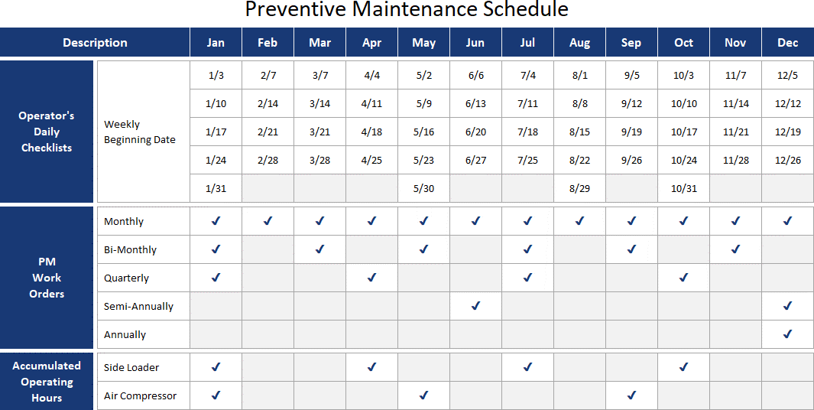

- Operator Preventive Maintenance of Equipment

1. Equipment Operator | The assigned operator on each shift performs Preventive Maintenance (PM) using the appropriate Operator's Daily Checklist form.  Completes all required/open checklists unless the equipment is formally tagged Out of Service (OOS) / Lock Out Tag Out status (LOTO).  The operator fills out one column, checking items off as completed. If an item needs repair the box is marked with an “R”. If that line item is  designated as a safety repair with “*”, the Warehouse Manager or Shift Supervisor is immediately notified and documented in the daily checklist. Mark CLOSED on days where applicable.
2. Warehouse | If item is designated a safety item, Warehouse Manager or Shift Supervisor
Manager, Shift | must complete MR001 and either repair immediately or follow proper lock
Supervisor, or | out procedure. Then, the request is logged in the Maintenance/Repair
designee | Request Log (MR002).

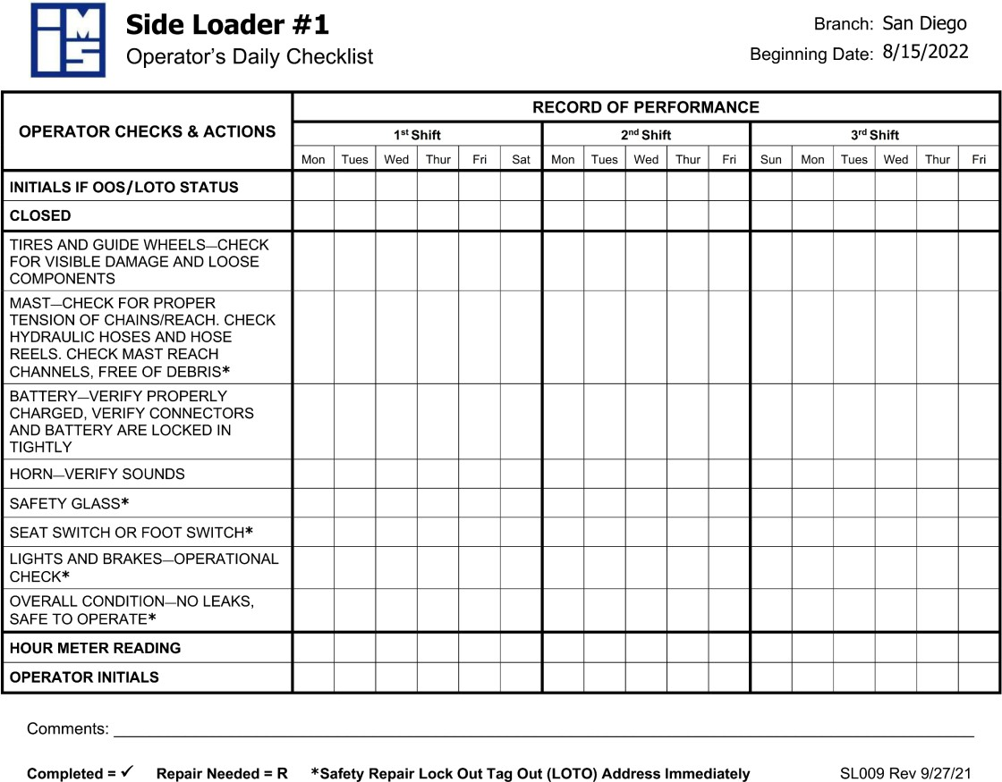

- Preventive Maintenance of Key Equipment

1. Quality Administrator or designee | For Key Equipment other than trucks, generates and prints out PM Work Order tasks monthly.  Files records of completed PM Work Orders.
2. Warehouse Manager, Lead Mechanic, or designee | Plans preventive maintenance actions according to PM Work Orders and regular truck maintenance schedule.  Purchases parts, supplies, equipment, or outside services required for preventive maintenance per QSP 6.2.
3. Warehouse Manager, Lead Mechanic, or Vendor | For Trucks owned and maintained by IMS, performs preventive maintenance if required by Truck and/or Tractor Maintenance & Safety Inspection (California only) (CHP 108), recording on form.  For other key equipment, performs preventive maintenance as required by PM Work Order checking off completed tasks per needed frequency.  Verifies that all required items are documented and forwards to Quality Administrator.

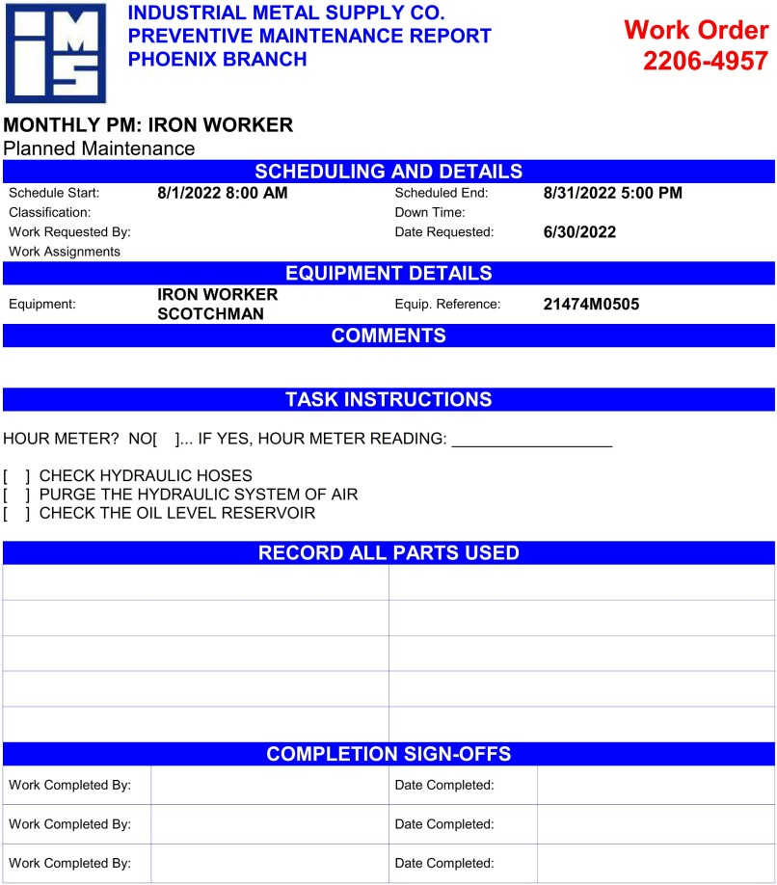

- Repair of Key Equipment

1. Warehouse | If necessary to repair equipment, purchases parts, supplies, equipment,
Manager, Lead | tools, or outside services per QSP 6.2.
Mechanic, or | Performs repairs as required through Maintenance/Repair Request
Vendor | (MR001).
 | Marks repair as complete in the Maintenance/Repair Request Log
 | (MR002).

Procedure Statements
- The Warehouse Manager maintains a list of “key” equipment that requires preventive maintenance and inspection to facilitate minimal downtime and impact to manufacturing. The Key equipment is defined as any equipment that is:
  - Operated at least weekly to satisfy customer orders,
  - Offers primary processing services to our customers,
  - Required by law to be inspected (i.e., powered lift equipment or cranes),
  - Required to be inspected for reasons of employee safety,
  - Other than hand tools, hand power tools, carts, strapping devices, or equivalent type equipment.
- Replacement parts are procured as required and sufficient inventory is maintained to minimize impact to order processing.
- Contracts are in place with vendors for some maintenance and repair services for key and non- key equipment per QSP 6.2.
- For non-key equipment, the Warehouse Manager, Lead Mechanic, or Vendor performs repairs or replaces equipment as required.
- Records of preventive maintenance and repair are maintained in accordance with QSP 5.1.
- The Quality Administrator or designee is responsible for gathering evidence required for the On-Time Performance reporting based on work order completion date on documents.
- Leased equipment, such as leased trucks, are maintained by Lessor, who keeps necessary records.
- Repairs to equipment must be evaluated within 30 days of the date that equipment was checked.
- The Shift Supervisor is responsible for checking all daily inspection records each shift for completion, and confirm all repairs designated as safety repairs are addressed.
- The Warehouse Manager is ultimately responsible for the entire process and for making sure equipment is maintained.
- All Warehouse personnel must be trained in the Lock Out Tag Out policy.

Risks and Mitigations

Risks | Mitigations
Inaction when measuring equipment is found to be unfit for its intended purpose and its impact on previous measurement results. Out of tolerance finding. | Managerial oversight on assignment of all calibrated equipment. Any order review findings on non-conforming tools are resolved through Corrective Action if needed.
Not having adequate supply of replacement parts or blades. | Maintenance schedule in place for all items and planned PM performed prior to each shift to identify specific needs for parts or blades in a timely fashion. Stock maintained by location or through vendor service.
Excessive time required to fulfill orders if key equipment breaks down. | Predetermined vendors for emergency repair as well as company mechanic on call. Lead time communication and sister branch support offer alternative lead times.
Not enough people trained in proper maintenance technique. | Designated and qualified company mechanic/ associate and outside vendors.
High workload level prevents planned maintenance from occurring per schedule. | Planned preventive maintenance program in place: daily, monthly, quarterly, semi-annual, annual.
Financial loss due to not following preventive maintenance schedules causing further damage to equipment. | Supervisors and Warehouse Manager accountable to checking status of all inspection records.

Reference and Applicable Documents
Quality Management System Manual (QSM-9000) Documented Information (QSP 5.1)
Purchasing and Supplier Evaluation (QSP 6.2) Validation of Static Measuring Devices (Appendix 1)

  - Performed by Machine Operator
Operator's Daily Checklist – Piston Air Compressor (AC001) Operator's Daily Checklist – Screw Air Compressor (AC002) Operator's Daily Checklist – Bridgeport Mill (BM001) Operator's Daily Checklist – Band Saw (BS001)
Operator's Daily Checklist – Aluminum Chop Saw (CH001) Operator's Daily Checklist – Steel Chop Saw (CH002)
Operator's Daily Checklist – Cutoff Machine (Bar Saw) (CM001) Operator's Daily Checklist – Do-All Circle Saw (CS002) Operator's Daily Checklist – Forklift (FL001)
Operator's Daily Checklist – Iron Worker (IR001) Operator's Daily Checklist – Jib Crane/Vacuum Lift (JC001) Operator's Daily Checklist – Overhead Crane (OC001) Operator's Daily Checklist – Order Picker (OP001) Operator's Daily Checklist – Precision Saw (PS001) Operator's Daily Checklist – PVC Machine (PV001) Operator's Daily Checklist – Shear (SH001)
Operator's Daily Checklist – AccurShear (SH002) Operator's Daily Checklist – Scissor Lifter (SL006) Operator's Daily Checklist – Side Loader (SL009) Operator's Daily Checklist – Stack U Rack (SR001) Operator's Daily Checklist – Tsune Cutoff Saw (TC001)
PacLease form: Post and Pre-Trip Inspection (or equivalent) (ETR 3496)
  - Performed by Warehouse Manager, Shift Supervisor, or designee Maintenance/Repair Request (MR001)
Maintenance/Repair Request Log (MR002)
  - Performed by Warehouse Manager, Lead Mechanic, or Vendor
Truck and/or Tractor Maintenance & Safety Inspection (California only) (CHP 108)

Personnel to be Trained
Warehouse Personnel Counter Sales Personnel Quality Administrator

Revisions Table

Date | Description of Change | Approved by
9/27/21 | Updated document format, created Bridgeport Mill daily checklist, and added Appendix to replace QSI 11.1.1 and QSI 11.1.2. | Melissa DaSilva Lonnie Johnson Victor Lopez
8/15/22 | Initial release SH002 Operator's Daily Checklist – AccurShear. | Lonnie Johnson
8/19/22 | Updated format, references, links, and included new equipment requirements. | Lonnie Johnson

Manager or Supervisors issue and record new Tape Measures and Slide Calipers going into service. Supervisor to validate new Tape Measure or Slide Caliper meet a no fail condition via Visual and Dimensional check.
Associates need to do a routine examination/check of their measuring device at least monthly or if they feel their device is no longer accurate or it is damaged.
If a device is lost, broken, or the employee is terminated, the device is to be removed from service.

Associate performs Visual check as follows:
- Tape Measures
Examines the rivets and holes in the hook at the tip. Either of the following conditions constitute a “Fail” condition:
  - Missing, bent or broken rivet.
  - Missing, bent or broken hook.
Examines the markings and tape body. Either of the following conditions constitute a “Fail” condition:
  - Illegible markings.
  - Bend or crease in tape.
- Slide Calipers
Either of the following conditions constitute a “Fail” condition:
  - Illegible markings and failure to read within 1/16”.
  - Bend or crease in slide rule or damage jaw blade.
- If any “Fail” condition was identified, do not continue validation.
  - Request Supervisor issues new Tape Measure.
  - Manager/Supervisor conducts impact assessment per QSM-9000.

Associate performs Dimensional check as follows:
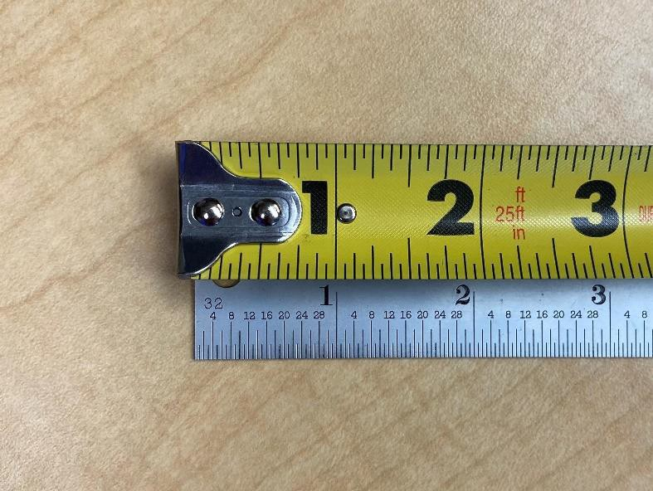
- Tape Measures
Hook the tip of the tape over the end of the Standard/Ruler. Use the Standard/Ruler to measure the length of your tape.

Associate performs Dimensional check as follows:
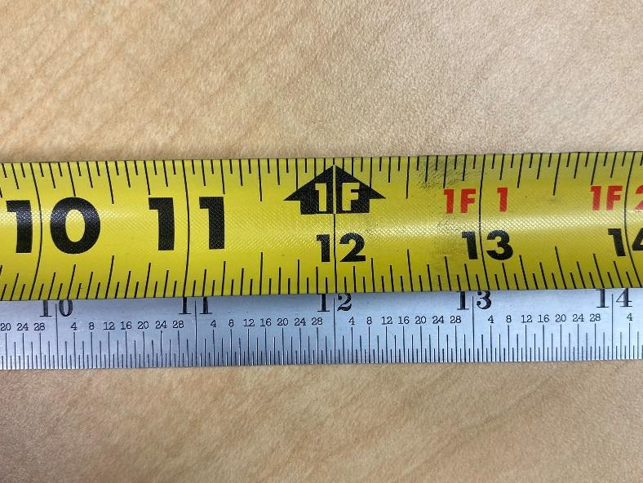Tape Measures
Check the length from the hook to:
The Tape Measure’s 12” marking.
An acceptable measurement is if the 12” mark on your tape lies
between 11-31/32” and 12-1/32” on the Standard/Ruler.
The Tape Measure’s 32” marking.
An acceptable measurement is if the 32” mark on your tape lies
between 31-15/16” and 32-1/16” on the Standard/Ruler.

- 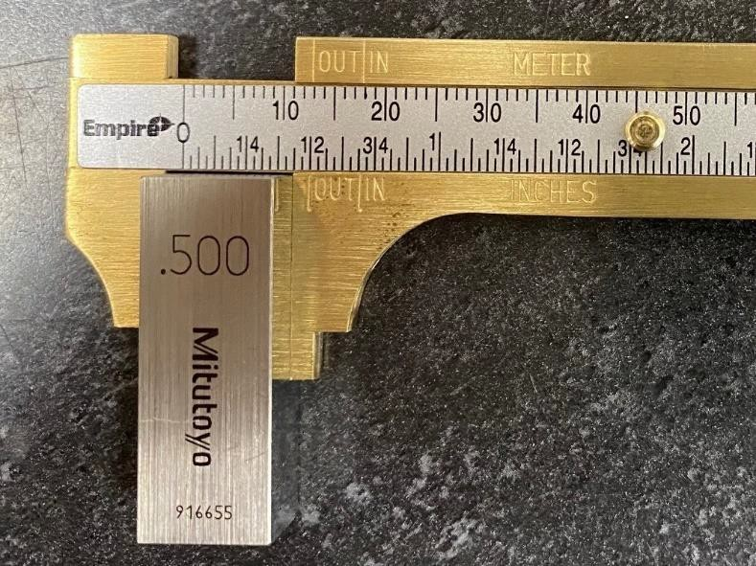Slide Calipers
Insert a 0.500 inch (12.7 mm) standard gauge block between the jaws used to measure outer diameters. Both the jaws should be in contact with the block but do not press the jaws too tightly on the surface. Take at least three readings to eliminate any inconsistency while measuring.
Repeat with a 1.000 inch (25.4 mm) gauge block.

Either of the following conditions constitute a “Fail” condition:
  - Inability to reach consistency in at least two readings.
  - Bent or loose slide rule; inability for jaws to make necessary contacts to gauge blocks.
- If any “Fail” condition was identified, do not continue validation.
  - Request Supervisor issues new Slide Caliper.
  - Manager/Supervisor conducts impact assessment per QSM-9000.

All other tools requiring certified calibration will be performed by outside calibration laboratory per the standard.

